musicALL Board Recruitment Pack: March 2026

About musicALL
musicALL is a Scottish charity creating inclusive music opportunities for young people with additional support needs who face barriers to mainstream music-making.
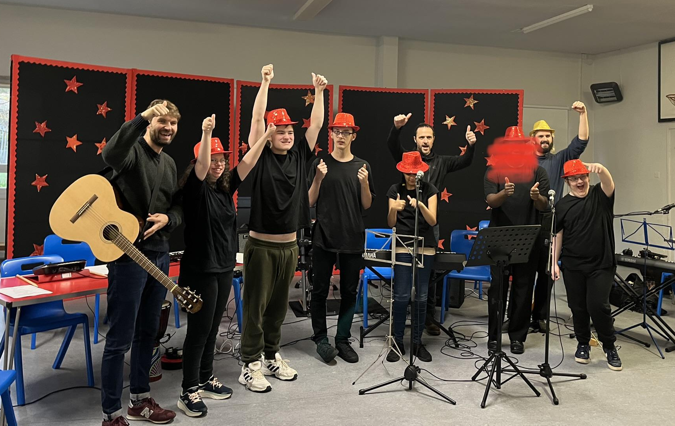
We work with young people who are neurodivergent, disabled, or who experience challenges within traditional education environments. Through inclusive music sessions, songwriting, performance and collaboration, we support young people to build confidence, creativity and a sense of belonging.
Our programmes are delivered in partnership with schools, local authorities and community organisations across Scotland. Sessions are led by professional musicians with experience in inclusive practice, creating welcoming environments where young people can explore music at their own pace.
musicALL believes that everyone should have the opportunity to make music and to be recognised for their creativity and potential.

Our Board and Current Position
musicALL is governed by a voluntary Board of Trustees who provide strategic oversight, support organisational development and ensure the charity operates responsibly and in line with its mission.
The organisation is currently entering an important transition. CEO Rob Gallagher will step down in June 2026 following a planned leadership transition. Programme Director Scott Mackay is preparing to take on the role of Executive Director.
musicALL now has a clearer programme pathway supported by diverse multi-year funding, strong partnerships with schools and local authorities, and a growing reputation for inclusive music practice.
As we move into the next phase of development, we are looking to strengthen the board with new trustees who can bring additional skills, perspectives and networks to support the organisation’s future growth.

Role of a Trustee
- Trustees help guide the strategic direction of musicALL and support the long-term sustainability of the organisation.
- Trustees are legally responsible for ensuring the charity is well governed, financially sound, and operating in line with its charitable purposes and Scottish charity law.
- Trustee details are registered with the Office of the Scottish Charity Regulator (OSCR), with trustee names normally appearing on the public Scottish Charity Register.
Working alongside fellow board members and the executive team, trustees contribute experience, insight and challenge to ensure the organisation continues to develop in line with its mission.
Trustees are not involved in day-to-day operations but provide oversight of strategy, governance and financial sustainability. They may also support the organisation through advocacy, partnerships or fundraising opportunities.
Previous board experience is not essential. We welcome individuals who are thoughtful, collaborative and committed to inclusive practice.

What We’re Looking For
We welcome trustees from a wide range of professional and lived experience backgrounds.
We are particularly interested in people with knowledge or experience in areas such as:
- Fundraising or business development
- Music industry or creative sector
- Charity leadership or governance
- Finance, legal or organisational development
- Education, youth work or inclusive practice
We are also keen to ensure our board reflects the diversity of the communities we work with and encourage applications from disabled and neurodivergent people and those under-represented in charity governance.

Our Values and Approach to Inclusion
Inclusion sits at the heart of musicALL’s work. We believe creativity should be accessible to everyone, regardless of ability, background or circumstance. Our programmes are designed to remove barriers to participation and create supportive environments where young people can explore music in ways that work for them. We aim to reflect these values in how we work as an organisation and how our board operates.

Time Commitment
Trustees attend around six board meetings per year, usually online and held in the early evening.
Once a year the board meets for a half day to work on future planning and strategy.
Occasional involvement in sub-groups or advisory discussions may be helpful depending on individual skills and interests. There are 4 finance committee meetings per year (optional).
Trustees are also encouraged to attend performances or programme activity and networking events where possible.

Why Join musicALL Now?
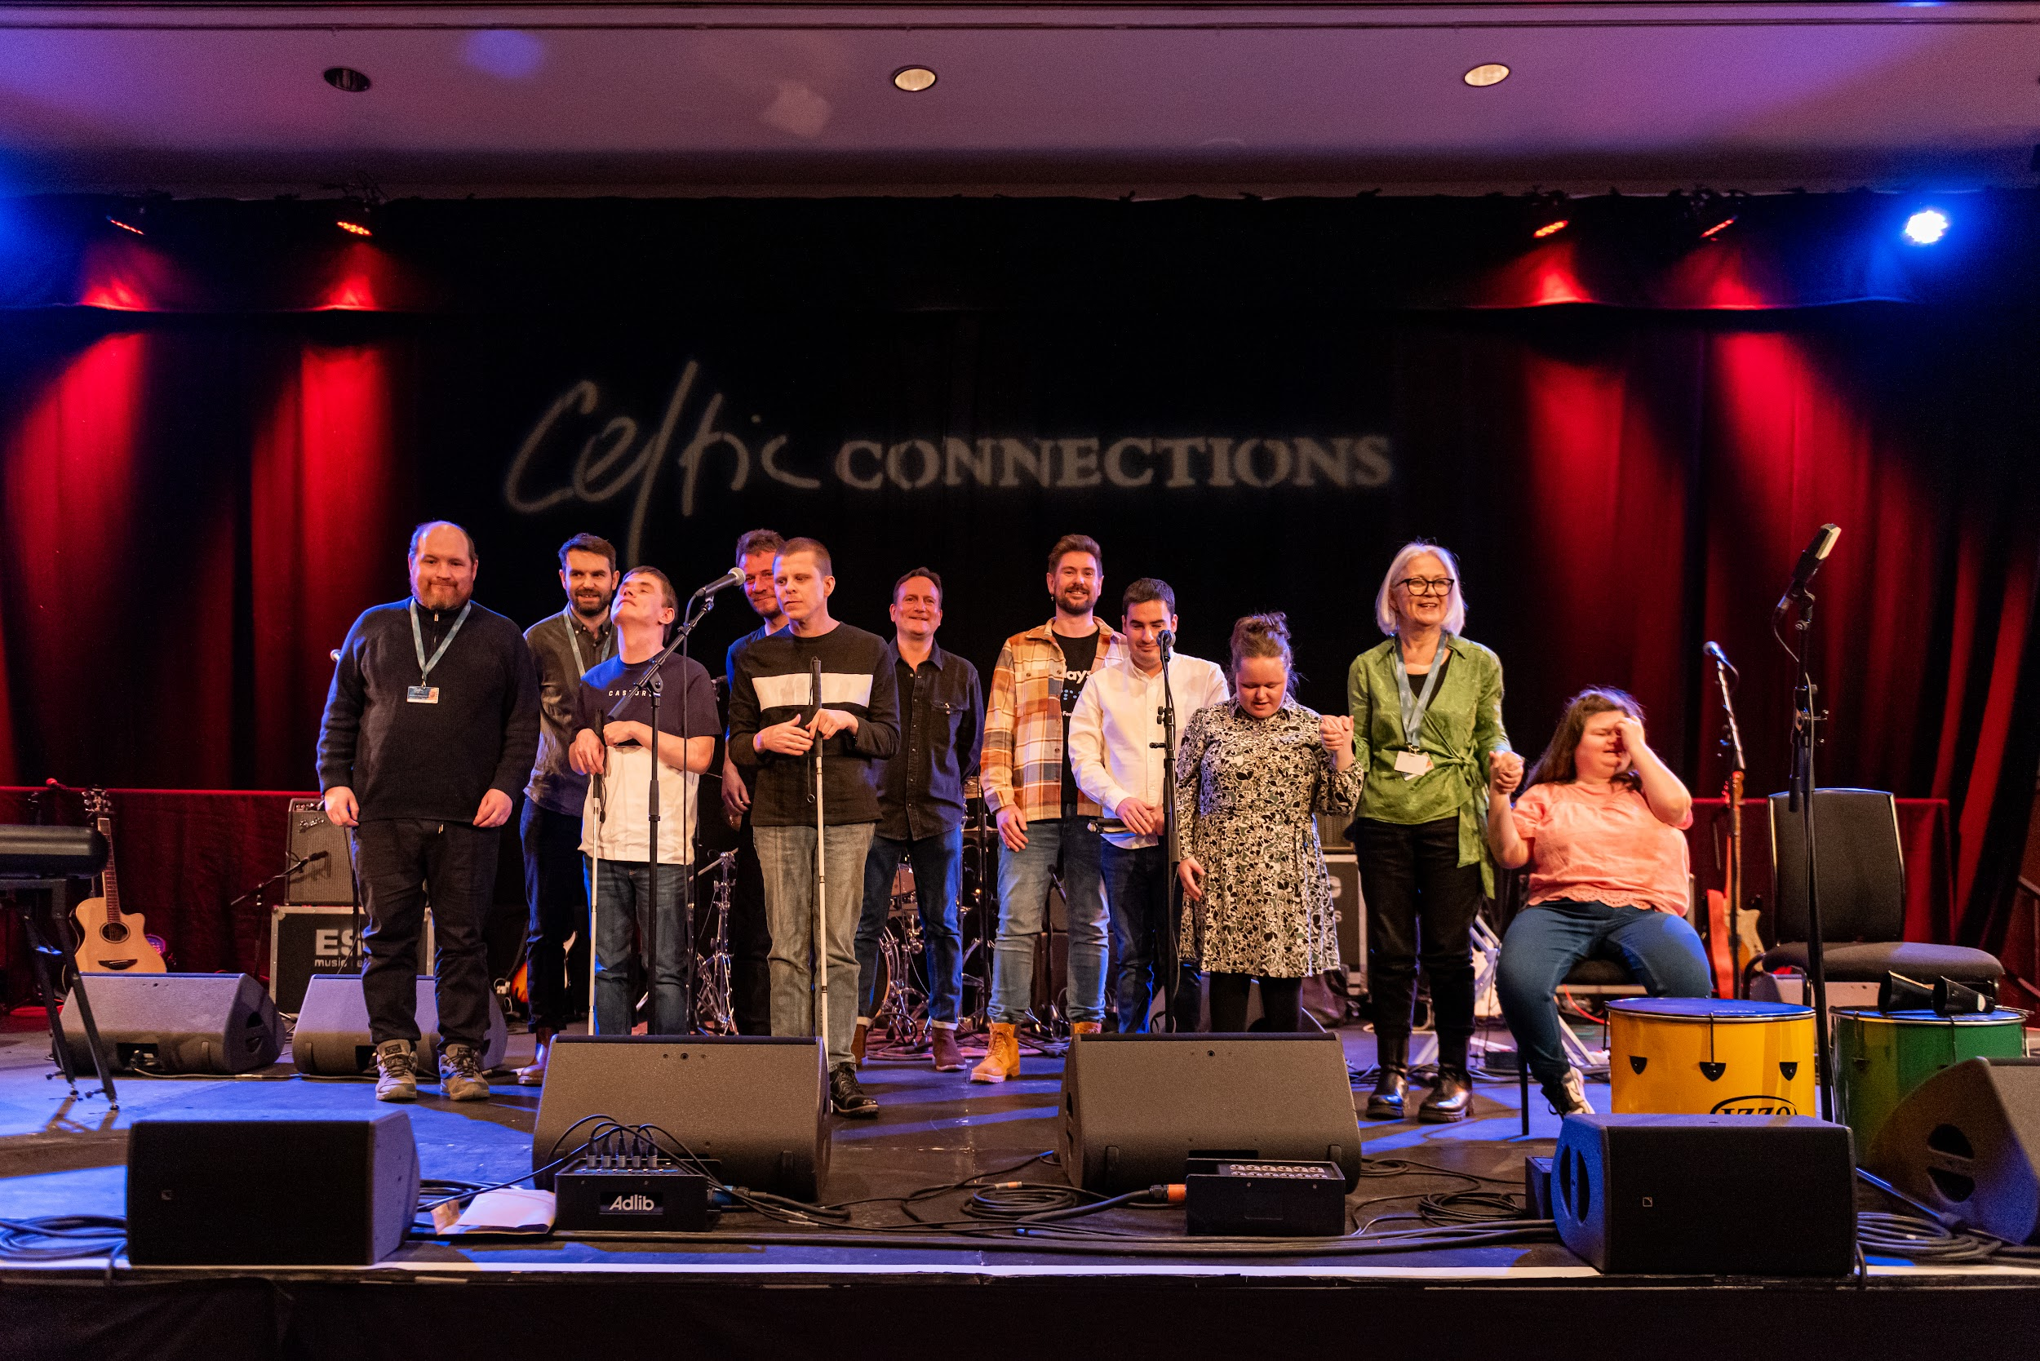
musicALL is entering a new stage of development, with a leadership transition and a growing programme model across Scotland.
This is an opportunity to join the board at a moment where thoughtful governance and fresh perspectives can help shape the organisation’s next chapter.
For those who care about creativity, inclusion and opportunities for young people, joining the board offers the chance to support a small organisation making a meaningful impact.

What You’ll Gain
Joining the board offers the opportunity to:
- Support an organisation making a real difference to young people
- Contribute your skills to a growing national charity
- Develop experience in charity governance and strategic leadership
- Connect with a network of creative and social sector professionals
How to apply:
To apply please send your current CV and a short email to Scott Mackay scott@musicallscotland.org.uk outlining your motivations for applying to join the board, and what experience you offer.

